SINGLE CELLS, BIG DATA: HOW ONE CELL CAN TELL A THOUSAND STORIES

Osatoyinbo Opemidimeji^{1*}, Vishnushiri Shyamsaisundar¹, Awosise Oluwaseun¹, Qonita Fillah¹, Abiodun Joy¹, Aakash Deva Thirukonda¹, Amin Abdurrahman¹, Alo Yetunde Mary¹, Brenda Namugamba¹, Opeoluwa Shodipe¹, Onah Victor¹, Ishita Chopra¹, Olorunfemi Popoola¹

Abstract: Advances in single-cell technologies have revolutionized our understanding of biological complexity by enabling transcriptomic profiling at single-cell resolution. Unlike traditional bulk RNA sequencing, which averages gene expression across heterogeneous populations, single-cell RNA sequencing (scRNA-seq) dissects tissues into their individual cellular components, revealing rare cell types, dynamic transcriptional states, and lineage trajectories previously obscured in population-level analyses. This article outlines the technological and computational foundations of scRNA-seq, from cell isolation and microfluidic encapsulation to barcoding, sequencing, and data interpretation. It further explores key applications, including the identification of master regulators in colorectal cancer differentiation, demonstrating how single-cell analysis drives discovery in disease modeling and therapeutic development. Finally, emerging trends such as multi-omics integration, artificial intelligence, and spatial transcriptomics are discussed as the next frontier in achieving a holistic, predictive understanding of cellular behavior. Collectively, these innovations mark a paradigm shift toward precision biology, transforming how we map, interpret, and manipulate the living cell.

Keywords: Single-Cell RNA Sequencing, Cellular Heterogeneity, Transcriptomics, Microfluidics, Bioinformatics, Cancer Reversion, Multi-Omics Integration, Artificial Intelligence, Precision Medicine.

INTRODUCTION
Biological tissues are not uniform. They are made up of many different types of cells, each playing its own role. This diversity is essential for how organisms develop, function, and respond to disease. However, for many years, scientists lacked the tools to examine this variation in detail. Traditional methods like bulk RNA sequencing measure gene expression by averaging the signals from thousands or even millions of cells at once. Although this approach has been very useful, it hides the unique characteristics of individual cells. As a result, rare cell types or subtle changes in cell state can be overlooked (Wu and Zhang 2020), hiding key biological differences relevant to processes like cancer development or immune response.

The development of single-cell RNA sequencing (scRNA-seq) was a complete game-changer in molecular biology. This technology provides a high-resolution lens capable of dissecting complex tissues into their constituent cellular units (Rawat et al., 2024). By isolating and profiling individual cells, scRNA-seq allows for the quantification of entire transcriptomes at an unprecedented resolution. For the first time, it is possible to map the cellular composition of any tissue, identify novel cell types, and trace developmental trajectories, effectively allowing us to see each cell.

However, this increase in resolution comes with a new challenge: data. A single scRNA-seq experiment can produce gene expression data for tens of thousands of cells, creating datasets of immense scale and complexity. This big data problem has forced us to build new and powerful computer programs and machine learning tools to filter, normalize, and interpret this high-dimensional data (Kharchenko, 2021).

As single-cell technologies become more widespread, they are driving major scientific efforts, including the Human Cell Atlas, which aims to create a comprehensive reference map of every cell type in the human body (Wen et al., 2022).

This article will chart the course of this revolution, from the limitations of bulk analysis to the high-definition world of single-cell resolution. We will explore the fundamental technologies, delve into the critical bioinformatics pipelines that translate raw data into biological insight, and discuss the groundbreaking applications that are reshaping our understanding of health and disease.

FROM BULKY BIOLOGY TO SINGLE-CELL RESOLUTION
RNA sequencing is a method to determine the number of actively expressed genes from a sample. For more than ten years, researchers have been using the traditional way, bulk sequencing, to investigate gene expression in various types of tissues, where the samples are usually obtained from one population of cells (Potter, 2018). This approach gives us the big picture of what is happening.

However, bulk sequencing can sometimes lead to inaccurate interpretation because its result reports the average expression of many different cell types, and hides the small yet crucial details. For example, studies revealed that tumor cells are actually heterogeneous, there could be numerous distinct tumor clusters found in the same tissue, and only a few of them are closely related to the proliferation or poor prognosis (Rich, 2016). These subtle variations are often missed in bulk RNA-seq. Here is where single-cell RNA sequencing (scRNA-seq) comes in as a game changer. This method has allowed researchers to examine the transcriptome of different cell types in the same tissue to get more precise results.

The first time scRNA seq was practised was in 2009, transcriptome of mouse primordial germ cells were sequenced. This was followed by several advancements focussing on high resolution snapshot of the cells. With better sequencing and computational advancements the utilisation of scRNA-seq has expanded its boundaries.

The fundamental difference between Bulk RNA sequencing and Single-cell RNA sequencing (scRNA-seq) lies in the fact that scRNA-seq considers each cell as an individual sample while a Bulk RNA-seq sample is an aggregate of cells. The high resolution nature of scRNA-seq makes it possible to detect a rare cell type which would be missed by the Bulk RNA-seq.

THE SCIENCE BEHIND SINGLE-CELL TECHNOLOGIES

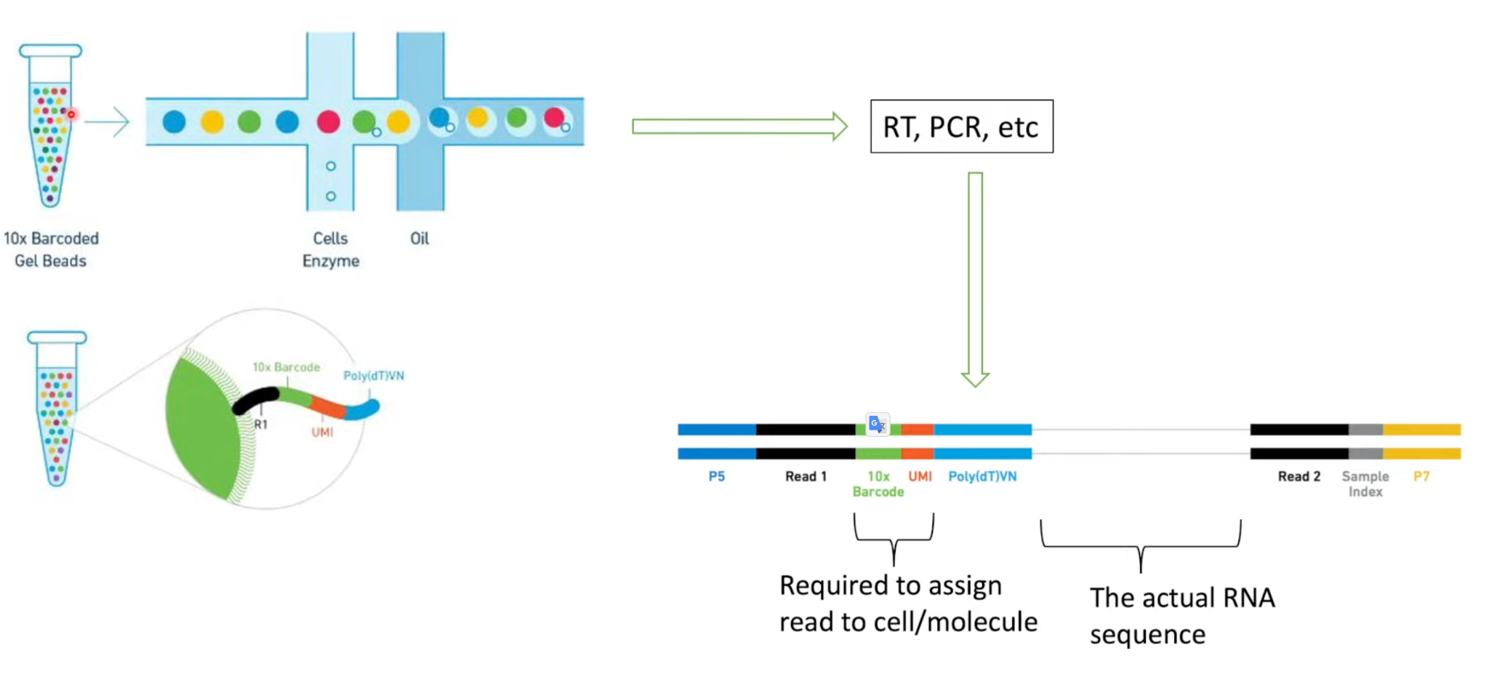
Figure 1: 10x Chromium microfluidics platform

1. Sample Preparation and Cell Isolation:
Generating a high-quality single-cell suspension from tissue or cell culture is a critical first step in scRNA-seq. A high-quality cell suspension ensures:
- Cell Viability and Integrity: RNA of a cell reflects the actual RNA, rather than technical artefacts.
- Single-Cell Resolution: Avoid clumping of two different cell types.
- Purity and Cleanliness: Free of Debris, Extra DNA or RNA or any artefacts.
- Reproducibility: Able to reproduce the workflow again, ensuring consistency and reliability.

This could be achieved by FACS or microfluidic platforms like 10x Chromium. The 10x Chromium microfluidics platform is widely used because of its efficiency and scalability. FACS is utilised when studying rare cell populations that require specific selection criteria. Figure 1 and the rest of the steps are based on the 10x Chromium platform.

2. Cell and Barcoded Bead Encapsulation:
The cell is encapsulated in an oil droplet along with a gel bead coated with barcoded primers. Each droplet ideally contains one cell and one gel bead, creating thousands of individual reaction chambers that operate in parallel.

This large-scale compartmentalisation is made possible by microfluidics devices, which precisely regulate the flow of cell suspension, barcoded beads, and oil through micro-scale channels to form uniform droplets.

Microfluidics devices achieve this by designing channel intersections to break down aqueous mixtures into discrete droplets by shearing them within a continuous oil phase. The flows are laminar and highly controllable, which ensures that each droplet captures exactly one cell and one bead with minimal errors, like multiple cells or empty droplets, resulting in a cell's RNA being encapsulated into an isolated droplet and avoiding any cross-contamination.

Components in gel bead that ensure precise capture and identification of RNA molecules from individual cells:
- A unique cell-specific barcode (10x barcode) that identifies which cell the RNA originated from.
- A unique molecular identifier (UMI) attached to each RNA molecule to track individual transcripts and correct for amplification bias.
- A poly(dT) sequence that captures mRNA molecules through hybridisation with their poly-A tails.
- Essential reagents, including enzymes for cell lysis, reverse transcription (RT), and other molecular biology steps necessary for cDNA preparation.

The droplets themselves remain stable due to the oil-based emulsification combined with surfactants, which form a protective shell around each droplet to prevent fusion or mixing. This stability is essential as it preserves the isolated microenvironments where enzymatic reactions convert mRNA to barcoded cDNA, enabling precise and accurate single-cell gene expression profiling.

This encapsulation strategy ensures that all RNA molecules from a single cell are tagged with the same cell barcode. At the same time, each transcript receives its own unique UMI, enabling precise tracking and quantification of gene expression at the single-cell level.

3. Reverse Transcription and PCR Amplification:
In each droplet, cell lysis releases the RNA, which hybridises to the bead's poly(dT) primers. Since the amount of RNA from a single cell is tiny, reverse transcription followed by PCR amplification is essential to generate sufficient material for sequencing. Barcodes and UMIs were incorporated into the resulting cDNA. During library preparation, each original RNA molecule is tagged with a unique, random sequence (UMI) before any amplification occurs. This tagging allows distinguishing between genuinely distinct RNA molecules and PCR duplicates generated during amplification. UMIs solve this problem by enabling computational collapsing of reads with identical UMIs and mapping positions, which represent PCR duplicates originating from the same initial RNA molecule. This collapsing prevents overcounting caused by amplification, providing a more accurate count of the original RNA molecules. UMIs allow correction for sequencing errors and detection of rare transcripts, enhancing the sensitivity and reliability of gene expression quantification.

4. Sequencing Library Preparation and Sequencing:
The amplified cDNA is prepared into sequencing libraries containing these barcoded fragments. These prepared libraries undergo paired-end sequencing on high-throughput platforms. With barcoded systems, we can identify each cell's transcripts.

5. Sequencing Reads and Assignment:
The sequencing output includes two key components:
Read 1: Contains the 10x barcode and UMI, which identifies the original cell and unique RNA molecule.
Read 2: Contains the actual RNA sequence of the transcript.
This allows us to attribute individual RNA molecules to specific cells and correct for amplification biases using the UMI.

BIOINFORMATICS AND DATA REPRESENTATION
A robust and effective computational and statistical analysis of the single cell data is inevitable to obtain meaningful insights from the large amount of sequencing data. Nearly 1000 different Bioinformatics tools focussing on the analysis of scRNA-seq data were already developed by May 2021 (Jovic et al., 2022). Computational analysis of the single cell data, broadens its applicability in life and clinical sciences. The Computational analysis of scRNA-seq data is a multistep process.
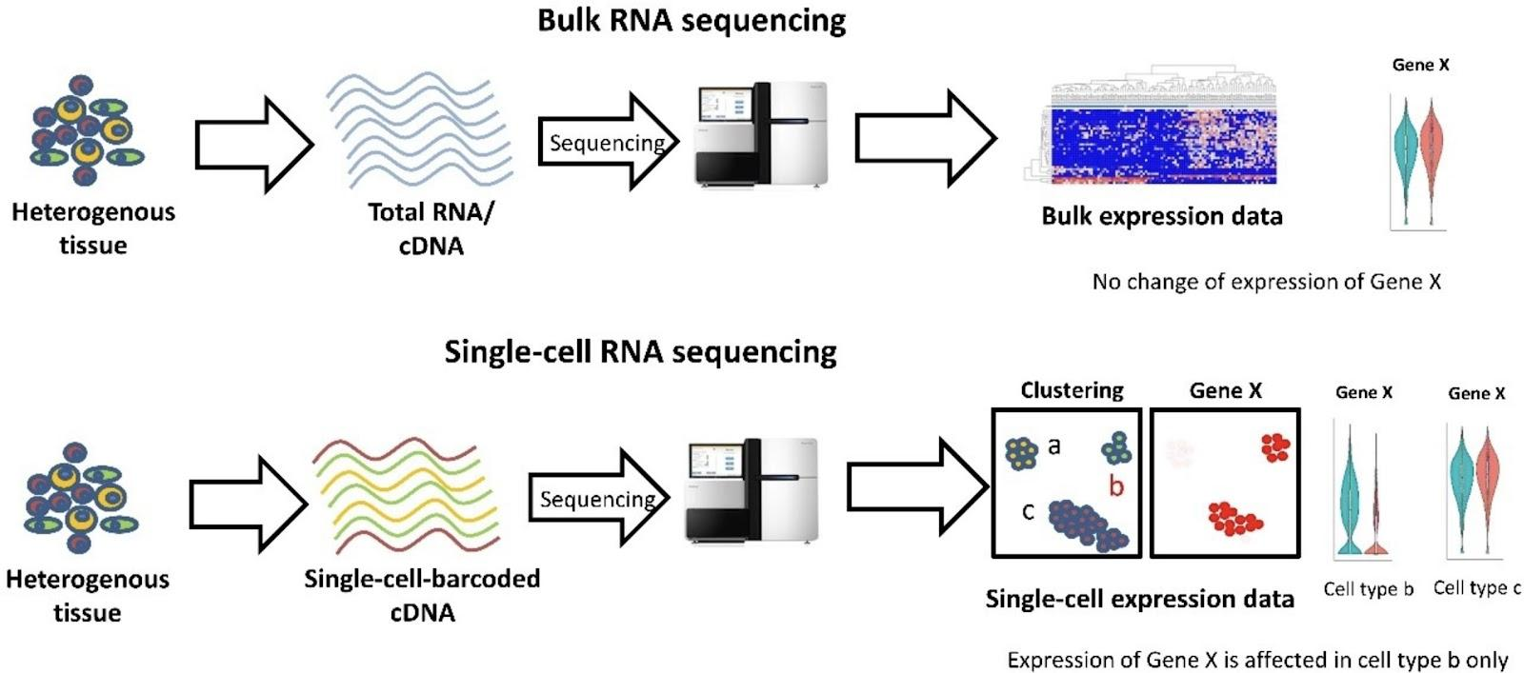
Figure 2: Overall difference in the insights unravelled through Bulk RNA sequencing and scRNA-seq

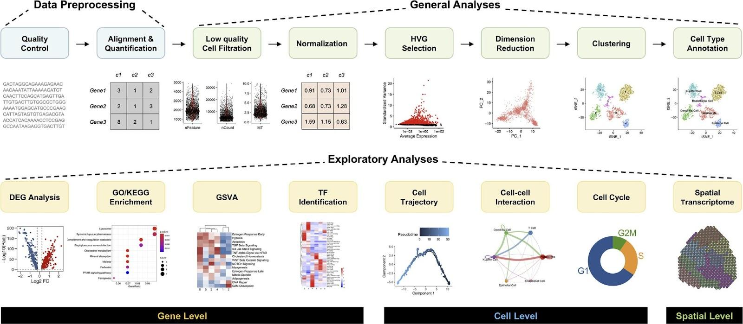
Figure 3: Roadmap for typical single-cell RNAsequencing data analysis.

Data Preprocessing:
Quality Control
The raw sequencing FASTQ reads first undergoes the process of Quality control. This is carried out using the widely used FastQC. The QC report is a lens to know the data in hand. It provides informative visualisations on the base quality, GC content, adapter content, read length and over represented sequences in the sample.
Data preprocessing includes trimming and filtering out, based on the sequence quality and content. This step ensures that downstream analyses are performed only on high-quality reads, improving the reliability and accuracy of the results.

Alignment and Quantification
The high quality reads are then mapped to the reference sequence -genome or transcriptome using appropriate aligner. For scRNA-seq data, splice-aware aligners like STAR are preferred. STAR uses annotation files to categorize the reads into introns, exons and intergenic based on their genome mapping site. The aligners report the gene centric raw expression counts.

General Analysis:
Low quality Cell filtration
A second round of quality control is carried out in scRNA-seq analysis procedure. This is split into cell QC and gene QC. Cell QC is carried out to get rid of all the cells that have not retained their natural viability during the experimental procedure. Cells may experience cell death, membrane damage, multi-cellular adhesion during the sample preparatory phase. These cells are unlikely to present a complete picture. Tools like seurat, scran,scanpy carry out the filtering based on criterias like the numbers of genes, the numbers of UMI (transcripts), the percentages of mitochondrial genes and the percentages of ribosomal protein genes in each cell (Jovic et al., 2022).

In case of the gene QC, genes that are not expressed or only expressed in extremely few cells, which are not informative of cell identity and cellular heterogeneity are filtered out. This is practiced when the data set is too big for limited computational resources (Wu and Zhang, 2020).

Normalization
In single cell sequencing each cell is treated as a sample, the original expression matrix is subjected to normalization due to the different sequence depth and transcript capture rate for each cell. Normalization is intended to counteract technical noise or bias and to ensure comparability between each cell (Jovic et al., 2022). There are several normalization methods; some studies show that different methods perform optimally for different datasets.

HVG selection
Most genes in the cells belong to housekeeping ones, they do not show variability in expression that can characterize cell types. Features that exhibit high cell to cell variation are called highly variable genes. HGVs show biological variance over technical variance. High quality HVG includes genes that can distinguish different cell types. Working with HVGs accelerates the downstream analysis by significantly reducing the computation volume. It should be noted that studies show that different HGVs detecting methods result in different runtimes and clustering results. Standard deviation, squared coefficient of variance are commonly used to estimate gene variance.

Dimension Reduction
scRNA-seq data is a high dimensional data, each gene represents a dimension. This high dimension has to be reduced to make it more interpretable and visualisable. There are linear and non-linear dimensionality reduction methods. PCA, the most widely used linear method has been successfully adopted for low throughput, in-depth scRNA-seq data analysis. PCA is most commonly used as a pre-processing step for non-linear dimensionality reduction algorithms. Non-linear methods like t-SNE and UMAP have been showing good performance handling high throughput scRNA-seq data.

Batch Correction
scRNA-seq data might contain batch effects due to non-biological but technological factors - different sequencing platforms, time, etc. This batch effect can have negative effects on the downstream processes and conclusion, hence batch effect correction is critical for scRNA-seq analysis.

Clustering and annotation
The key idea of scRNA-seq is the ability to characterise the heterogeneity in the cell population at the single cell level. The heterogeneity can be in cell types and also cell states of the same cell type. Clustering is an important step to group the cells by their expression profiles. Cells with similar expression patterns are considered as the same cell types / cell states.
- Supervised clustering: Clustering approaches that classify the cells based on the prior known information like cell type specific marker genes.
- Unsupervised clustering: Clustering entirely based on the data itself- k means clustering, which clusters the data point according to its proximity to the cluster center.
The clustering algorithms have parameters whose values significantly influence the outcome of the method.
Annotation is closely tied to the clustering process. Annotation is done by extracting marker genes from the data or by doing transcriptome profiling. Differential expression testing is a method to identify the marker genes, using statistical tests like the t-test and the Wilcoxon test the strongly differentially expressed genes are identified. Top ranking genes of the identified list are considered as marker genes. Scamp and Garnett are automated annotation tools that are easy to use and fast in computation (Pliner et al., 2019). These automatic annotation methods' performance is compromised when rare and new cell types are to be defined. This is because of the limited data on the marker genes that is available.

Exploratory analysis
Many downstream analyses like functional enrichment analyses are carried out to know the functional and biological significance of the clusters. Gene set variation analysis (GSVA) is a widely used enrichment analysis. Along with it there are analyses and methods to identify transcription factors enriched in each cluster; Pseudo-time analysis is carried out to know the trajectory of the cell states at single cell level; Cell-Cell communication analyses are done to infer co-participation and coordination of multiple cell types; There are machine learning based methods to predict the cell-cycle stages from single cell RNA sequencing data.

BIOLOGICAL INSIGHTS AND APPLICATIONS
Single-cell RNA sequencing (scRNA-seq) is a powerful tool that enables biologists to explore gene expression at unprecedented resolution. The vast amount of data it generates allows its application across many areas of biology and medicine. Researchers leveraged scRNA-seq data and applied Boolean logic to uncover key regulatory factors driving the differentiation of colorectal cancer cells (Ogbeidi, 2024).

Cancer as a disease refers to an umbrella of diseases that share several characteristics. These characteristics include resisting cell death, genome instability and mutation, as well as nonmutational epigenetic reprogramming, to name a few. The central theme of this study is the challenge of systematically identifying master regulators across normal differentiation processes that could be used for cancer reversion therapy. Cancer reversion is proposed as a therapeutic approach aimed at reverting malignant cells into a differentiated, non-malignant state (Ogbeidi, 2024).

This study looks into colorectal cancer and focuses on enterocyte differentiation (which are epithelial cells which line the inner surface of the small and large intestines) as a model for cancer reversion. In their study, they had obtained publicly available single-cell transcriptome data of normal human colon and rectum samples (accession number GSE125970). For the core analysis, 4252 single cells corresponding to stem cells and enterocytes were selected to construct a Boolean Gene Regulatory Network (BGRN) model for enterocyte differentiation. The BGRN model utilises single-cell transcriptome data, specifically leveraging mature and pre-mature RNA information of transcripts to split the transcriptional status of each single cell into pre- and post-transition dynamical states. This enables the inference of more accurate regulatory logic.

From there, the researchers have narrowed down three genes that act as master regulators for inducing enterocyte differentiation: MYB, HDAC2, and FOXA2. To validate the in silico findings, the researchers conducted triple gene silencing of these three genes in vitro using three colorectal cell lines and in vivo using mice. What they found was that triple silencing of these genes significantly reduces cancer activity in cell lines, and also results in a significant reduction of tumour size in mice. This study highlights how single-cell resolution data can effectively narrow down the search for critical genes involved in colorectal cancer to just a few key regulators.

If the researchers had instead used bulk RNA-seq data, they would have lost the ability to resolve the dynamic states of individual cells. Bulk RNA-seq captures the average gene expression across a population of cells, making it challenging to distinguish variations in expression levels between different cell types or differentiation stages. As a result, it would not have been possible to infer cellular trajectories or detect the heterogeneity underlying colorectal cancer differentiation. In contrast, scRNA-seq enables the analysis of both mature and pre-mature RNA transcripts at the single-cell level, allowing researchers to elucidate how gene expression changes during cell fate transitions.

CHALLENGES AND ETHICAL CONSIDERATIONS
Single-cell technologies have revolutionized the way we study biology, allowing researchers to profile gene expression, chromatin accessibility, and protein activity at an unprecedented resolution. These approaches uncover the cellular heterogeneity that bulk analyses mask, offering insights into development, disease, and therapy response (Wu et al., 2024).
Yet, this transformation comes with practical and ethical challenges.

1. Technical and Analytical Challenges
Data complexity and computational demand:
Single-cell omics generate vast, complex, and multidimensional datasets that capture gene expression, epigenetic, and proteomic information from thousands or even millions of individual cells. Managing these datasets requires advanced computational tools and scalable storage systems. The integration of multiple data modalities, such as transcriptomic and chromatin accessibility data, remains a key challenge in maintaining accuracy across platforms (Oder et al., 2023).

Integration and scalability:
Large collaborative efforts like the Human Cell Atlas have highlighted the need for harmonized data integration methods. Without consistent standards, batch effects and inconsistent annotations can distort biological conclusions (Rood et al., 2022). As single-cell datasets continue to grow, computational scalability and interoperability across platforms remain unresolved technical barriers.

2. Ethical Considerations
Privacy and data protection:
Single-cell genomic data, even when anonymized, can still be linked to individuals. Re-identification through genomic variants or metadata poses privacy risks, especially when datasets are publicly shared (Kramanns et al., 2025). Researchers must adopt controlled-access systems and follow strict data governance protocols to protect participants’ identities.

The rapid evolution of single-cell science demands equally rapid development of ethical frameworks and data governance strategies. Balancing openness with privacy, innovation with responsibility is essential to ensure that single-cell research advances science while protecting individual rights and promoting equitable access.

THE FUTURE OF SINGLE-CELL SCIENCE
The future of single-cell science is rapidly evolving toward a truly integrative and predictive biology, where the complexity of living systems can be decoded across multiple molecular layers and spatial dimensions. The convergence of single-cell sequencing, multi-omics, and computational modeling is transforming biological research from descriptive observation to holistic interpretation (Wu et al., 2024).

By combining genomic, transcriptomic, proteomic, and epigenomic data within individual cells, scientists are beginning to construct multidimensional cellular atlases that capture the full spectrum of heterogeneity and dynamic plasticity inherent in biological systems. Future innovations will depend heavily on artificial intelligence and machine learning, which can synthesize these vast data streams to reveal emergent cellular behaviors, predict functional outcomes, and guide precision medicine.

Furthermore, the integration of spatial and temporal resolution, will enable researchers to visualize cellular interactions within intact tissues and developmental contexts, providing an unprecedented window into the architecture of life at single-cell resolution (Wu et al., 2024). Collectively, these advances mark a paradigm shift from static, population-level analyses to a data-driven, dynamic understanding of cellular ecosystems, defining the next frontier in single-cell science.

1. The Rise of Integrative Multi-Omics
The next frontier of single-cell research lies in multi-omics integration, where multiple biological layers, genomics, transcriptomics, epigenomics, proteomics, and metabolomics, are simultaneously analyzed in individual cells. The integration of multi-omics data enables scientists to unravel regulatory mechanisms that are undetectable when examining each omic layer in isolation (Wu et al., 2024). This comprehensive approach provides a holistic perspective of cellular function, facilitating the identification of new biomarkers and disease mechanisms.
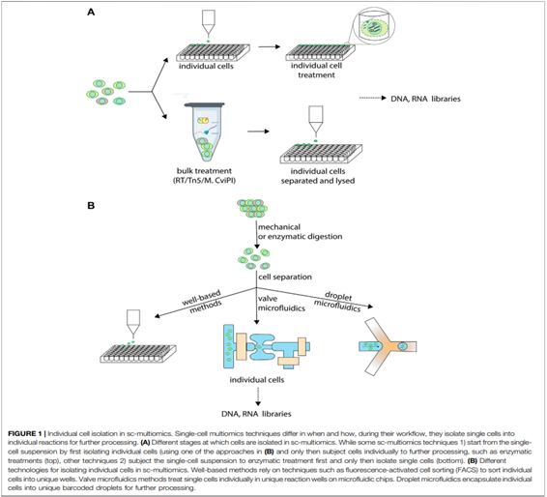
Figure 4: Workflow for single-cell multi-omics data integration (Frontiers in Cell and Developmental Biology,10:854317).

Future advancements are expected to focus on improving the scalability and accuracy of multi-omics pipelines. As data volume increases, new bioinformatics algorithms will be essential for integrating and interpreting these complex datasets efficiently. Computational harmonization across modalities will require deep learning frameworks capable of recognizing shared patterns across diverse biological features.

2. Artificial Intelligence and Predictive Modeling
Artificial intelligence (AI) and machine learning (ML) are increasingly becoming central to the future of single-cell analysis. As sequencing technologies continue to generate vast and complex datasets, AI-driven approaches are transforming how scientists interpret cellular behavior. Future AI systems will progress from descriptive analysis to predictive modeling, capable of simulating cell states, lineage trajectories, and disease evolution (Noller et al., 2025). By incorporating deep neural networks into multimodal single-cell data analysis, researchers can achieve greater precision in predicting therapeutic responses and disease susceptibility.

Single-cell sequencing methods, such as single-cell RNA sequencing (scRNA-seq), have become widely used in both basic and translational research for measuring transcriptomic activity at the cellular level. Each cell is typically isolated from its tissue using techniques like fluorescence-activated cell sorting (FACS), laser capture microdissection, or microfluidics. Droplet-based platforms such as Drop-seq and 10× Genomics Chromium allow unbiased analysis of thousands of cells, while nanopore sequencing offers full-length sequence data and insights into splicing and transcript diversity. Emerging innovations like split-pooling and the use of unique molecular identifiers (UMIs) help reduce errors and bias during sequencing. By combining these cutting-edge sequencing technologies with AI and ML frameworks, future single-cell research will not only deepen understanding of cellular heterogeneity but also enable predictive modeling for precision medicine and disease management.
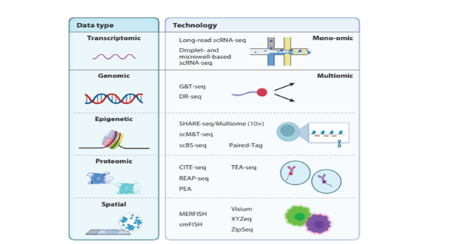
Figure 5: Conceptual framework for multimodal data harmonization in single-cell biology (Review of Biomedical Data Science, 6:313–337)

Moreover, as AI models evolve, they will enable cross-platform learning, where insights gained from one biological system (e.g., human tissue) can be transferred to another (e.g., model organisms). This will accelerate the translation of single-cell findings into clinical and pharmaceutical applications.

3. The Spatial and Temporal Frontier
While single-cell sequencing captures molecular information from isolated cells, the next generation of research aims to preserve spatial and temporal context. The integration of spatial transcriptomics and spatiotemporal modeling allows scientists to visualize how gene expression varies within intact tissues. Mapping the spatial gene landscape of the developing human kidney, reveals dynamic cell–cell interactions that underlie organ formation (Wu et al., 2024).
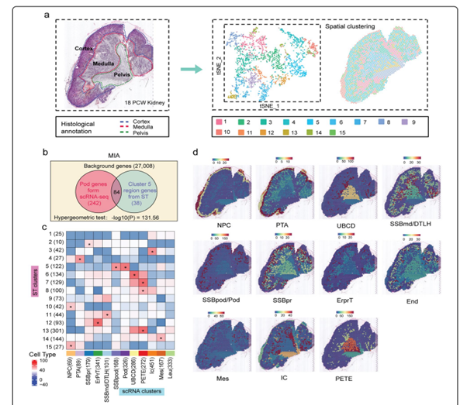
Figure 6: Spatial transcriptomic map of human kidney development (Cell & Bioscience, 12:80).

Future innovations will likely combine spatial omics with live-cell imaging and temporal sampling, allowing real-time tracking of cellular differentiation and response to stimuli. This convergence will transform our understanding of organ development, disease progression, and therapeutic response.

4. Challenges and Emerging Directions
Despite remarkable progress, several challenges persist. Data integration remains computationally demanding, as single-cell datasets are high-dimensional and heterogeneous .

Furthermore, issues of reproducibility and data sharing hinder collaborative advancement. However, open-access initiatives and standardized pipelines are being developed to promote transparency and interoperability across laboratories (Leins et al., 2023).

In the near future, the field is expected to adopt real-time single-cell profiling technologies that can monitor gene expression dynamically, as well as low-cost sequencing platforms for broader accessibility. The ultimate vision is a digital cell atlas, a dynamic, data-driven model capturing the molecular and spatial behavior of every cell type under varying physiological conditions.

5. Vision for the Next Decade
Looking ahead, single-cell science is poised to redefine personalized medicine and precision biology. Leveraging single-cell data to explore the genetic basis of complex traits will enable personalized interventions that target specific cellular subtypes. Similarly, advances in spatial multi-omics and AI-driven analytics are expected to bridge the gap between molecular biology, systems biology, and clinical practice.

By 2035, researchers anticipate a fully integrative single-cell ecosystem; combining molecular data, spatial coordinates, and temporal progression; capable of predicting cellular fate, disease onset, and therapeutic outcomes in a computationally unified framework. The convergence of these technologies signifies not only a methodological revolution but also a paradigm shift in how we perceive and manipulate living systems.

CONCLUSION
The evolution from bulk RNA sequencing to single-cell resolution marks a defining shift in molecular biology, transforming how researchers conceptualize and investigate cellular heterogeneity. While traditional bulk sequencing provided valuable insights into gene expression patterns, it masked the intrinsic diversity and dynamic states present within complex tissues. The advent of single-cell RNA sequencing (scRNA-seq) overcame these limitations by enabling high-resolution analysis of individual transcriptomes, thereby unveiling rare cell types, developmental trajectories, and disease-associated subpopulations that were previously obscured in population-averaged data.

The realization of single-cell sequencing was made possible through incremental yet transformative technological advances. Improvements in cell isolation methods, microfluidic systems, nucleic acid amplification chemistry, next-generation sequencing platforms, and computational bioinformatics collectively bridged the gap between conceptual potential and practical implementation. These innovations not only enhanced sensitivity and scalability but also addressed critical challenges related to amplification bias, sequencing depth, and data integration, establishing scRNA-seq as a cornerstone of modern molecular analysis.

The biological insights gained through single-cell technologies have been profound. By resolving gene expression at the individual cell level, scRNA-seq has enabled the identification of cellular hierarchies, elucidated lineage differentiation pathways, and revealed transcriptional regulators that drive pathological states, such as those observed in colorectal cancer. Such findings underscore the ability of single-cell approaches to transcend descriptive biology, providing mechanistic frameworks for disease modeling, therapeutic target discovery, and regenerative medicine.

As the field progresses, single-cell science is rapidly converging with multi-omics, artificial intelligence, and spatial transcriptomics to generate a more comprehensive and predictive understanding of biological systems. These integrative approaches promise to unify molecular, spatial, and temporal dimensions of cellular behavior, ultimately allowing researchers to construct dynamic models that simulate cellular responses under physiological and pathological conditions. Despite ongoing challenges in data harmonization, reproducibility, and computational scalability, current trends indicate that single-cell research will continue to redefine precision biology and personalized medicine.
In summary, single-cell technologies have transformed the scale and resolution at which biological complexity can be observed and interpreted. By enabling the study of individual cells within their native context, these approaches have expanded the frontier of genomics from static population averages to dynamic, data-driven interpretations of cellular ecosystems. The ongoing integration of multi-omics and computational modeling represents the next phase of this revolution, one in which the stories of single cells collectively illuminate the fundamental principles that govern life itself.

REFERENCES
Jovic, D., Liang, X., Zeng, H., Lin, L., Xu, F., & Luo, Y. (2022). Single‐cell RNA sequencing technologies and applications: A brief overview. Clinical and translational medicine, 12(3), e694.
Kharchenko, P. V. (2021). The triumphs and limitations of computational methods for scRNA-seq. Nature methods, 18(7), 723-732.
Kramann, R., Kuppe, C., Luyckx, V., Van Biesen, W., & Steiger, S. (2025). Unveiling the risks: protecting privacy in single-cell genomics data. Nephrology Dialysis Transplantation, 40(6), 1077-1080.
Leins, D. A., Haase, S. B., Eslami, M., Schrier, J., & Freeman, J. T. (2023). Collaborative methods to enhance reproducibility and accelerate discovery. Digital Discovery, 2(1), 12-27.
Noller, K., Botsis, T., Camara, P. G., Ciotti, L., Cooper, L. A., Goecks, J., ... & Bakas, S. (2025). Informatics at the Frontier of Cancer Research. Cancer Research.
Oder, B., Chatzidimitriou, A., Langerak, A. W., Rosenquist, R., & Österholm, C. (2023). Recent revelations and future directions using single-cell technologies in chronic lymphocytic leukemia. Frontiers in Oncology, 13, 1143811.
Ogbeidi Igbinoba, S. U. (2024). Single-cell multiomics profiling in the study of colorectal cancer evolution (Doctoral dissertation, University of East Anglia).
Pliner, H. A., Shendure, J., & Trapnell, C. (2019). Supervised classification enables rapid annotation of cell atlases. Nature methods, 16(10), 983-986.
Potter, S. S. (2018). Single-cell RNA sequencing for the study of development, physiology and disease. Nature Reviews Nephrology, 14(8), 479-492.
Rawat, S., Sharma, Y., & Mohanty, S. (2024). The single-cell big data analytics: A game changer in bioscience. In Computational Biology for Stem Cell Research (pp. 115-128). Academic Press.
Rich, J. N. (2016). Cancer stem cells: understanding tumor hierarchy and heterogeneity. Medicine, 95(1S), S2-S7.
Rood, J. E., Maartens, A., Hupalowska, A., Teichmann, S. A., & Regev, A. (2022). Impact of the Human Cell Atlas on medicine. Nature medicine, 28(12), 2486-2496.
Wen, L., Li, G., Huang, T., Geng, W., Pei, H., Yang, J., ... & Chen, Z. J. (2022). Single-cell technologies: From research to application. The Innovation, 3(6).
Wu, X., Yang, X., Dai, Y., Zhao, Z., Zhu, J., Guo, H., & Yang, R. (2024). Single-cell sequencing to multi-omics: technologies and applications. Biomarker research, 12(1), 110.
Wu, Y., & Zhang, K. (2020). Tools for the analysis of high-dimensional single-cell RNA sequencing data. Nature Reviews Nephrology, 16(7), 408-421.

